Certification guideline and assessment tool
With inclution in this project we think of
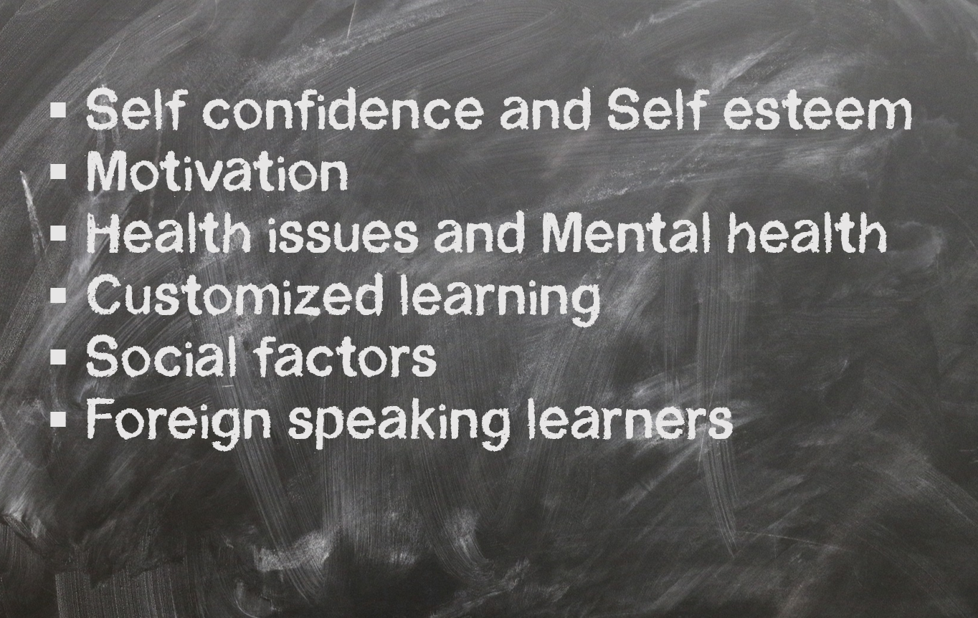




Table of Contents
Certification assessment process 3
Introduction 3
The context 4
Why assess trainers and educators in adult education? 4
Standards of conducting the assessment 6
What is measured and what is not measured 6
Organizing of assessment 7
Review of competencies 7
Assessment after conducted eLearning 7
Assessment after conducted face-to-face training 8
Methodology of the three steps of assessment 8
Review of competencies 8
Assessment after conducted eLearning 9
Assessment after conducted face-to-face training 9
Requirements for the certification body 9
Management of impartiality 9
Confidentiality 9
Changes affecting certification 10
Termination, suspension, or withdrawal of certification 10
Evaluation and revision of assessment process 10

Certification assessment process

Introduction
The overall aim of certifying an adult educator is giving confidence to all interested parties that their training and learning activities fulfil specific requirements. Certification for adult educators is one means of providing assurance that the certified person meets the requirements of the certification scheme. Confidence in the respective certification schemes for individuals is achieved by means of a globally accepted process of assessment and periodic re-assessments of the competence of certified people.

An adult educator in this document is defined as a person conducting training or learning activities within specific topics for adults.
The value of certification is the degree of confidence and trust that is established by an impartial and competent demonstration of fulfilment of specific requirements by a third party. Stakeholders that have an interest in certification are included, but are not limited to:
- the clients of the certification bodies
- the customers of the organizations whose products, processes or services are certified
- governmental authorities
- non-governmental organizations
- consumers and other members of the public

Stakeholders can expect and require certified adult educators to meet all the requirements which are put in place by Included Education.
Certification of the adult educators is specified for the different professional topics the Included Education project is working on.

The context
The target group for certification are educators, trainers and teachers working with youths or young adults. It can be in formal school system or in other training and educational setting. In this document we call them all adult educators and the students’ adult learners.
The certification covers knowledge and skills necessary for an adult educator to deal with learners having personal issues which might give less learning outcome if the educator is not aware of it and able to deal with it. We are talking of learners attending normal groups or classes. The knowledge and skills provided to the educators are not meant to replace tasks the special pedagogy teachers do, more to be able to deal with the learners personal issues as a normal part of their teaching.
The personal issues covered in the certifications process is defined as
- Self-confidence / Self- esteem
- Motivation
- Health issues (risk factor) / Mental health
- Customized learning
- Social factors (difficult background, friendship, low educational level family, environment etc.)
- Foreign speaking learners

Why assess trainers and educators in adult education?
Research conducted as part of preliminary work stated that at educators’ needed competence in order to give learners with personal issues better learning outcome. The same studies also concluded that European countries have few and in some case no quality measurement for supporting learners with such personal issues.
The overall aim of certifying an adult educator is giving confidence to all interested parties that their training and learning activities fulfil specific requirements. Certification for adult educators is one means of providing assurance that the certified person meets the requirements of the certification scheme. Confidence in the respective certification schemes for individuals is achieved by means of a globally accepted process of assessment and periodic re-assessments of the competence of certified people.
In the changing context of education and, in particular, in the process of adult learning, it is important to focus on people who are in the role of educators. It's not just about teaching strategies due to change of direction from formal to non-formal and informal education, but also to understand the learners to be the source of knowledge. This change gives expectation that they will take on the role of facilitators or moderators. The main interest of the institutions and organizations offering courses, training, or informal adult education is an understanding of what demands they have to educators in adult education. What kind of competencies are expected from educators in order to hire them and keep them in the adult education system?

There is no universal framework or common references on competence to assess what makes an adult educator a "good teacher". And there is always a risk that assessment measures a limited range of "technical skills" or a simplistic list of competencies that are easy to measure but may not be key factors in assessing an educator’s ability.
As mentioned above, adult educators perform different roles and therefore need to have a wide range of competencies enabling them to motivate adult learners and to impart their knowledge to them.
So, why assess trainers and educators in adult education?
Educational control
Establishing national standards and national assessment can be a way to link developed curriculums and teaching, based on what we all assume is proper knowledge and teaching skills in adult education.
Expectation of customer
Adult education is often kind of on-the-job training. This means the customer of adult education and trainer typically are the employer in terms of ordering or approving the training and often also paying and facilitating the training.
In other cases, the learner him/herself is the customer, requesting training based on personal needs.
As in other markets, the customers within adult education should know the quality standards of those persons providing the training.
Self-reflection

When the assessment of teachers is done well and involves those being evaluated, it can provide a chance for educators to reflect on their daily practices and improve. In some cases, the assessment process also supports educators who may be lacking in pedagogic expertise or who have basically been thrown into classrooms without sufficient training.

Standards of conducting the assessment
In many cases, the assessment is not well organized and has little impact on teaching. More importantly, the assessment is too frequently insulting to educators, especially when those doing the evaluating are out of touch with the realities of classroom life. In such an approach, assessment is used to merely show what is being done wrong and is not designed to provide truly helpful feedback on how one can do better.

Having this in mind, the training centres giving educators mandatory training and later conduct the assessment, need themselves to understand the conditions and context which the training happens.

What is measured and what is not measured
The assessment as part of the certification process will assess the learning outcome from mandatory eLearning and face-to-face training. This training is covering the minimum of requested competencies within each topic, highly connected to learning situations.
The assessment will not measure
- the educator’s ability to transform his/her knowledge into teaching practice
- how well the educator is performing in the classroom
- their ability to fulfil the learning contract with customers.
All those are considered as a task for the educator’s employer or customer to have an opinion about.

Organizing of assessment
The assessment will be conducted in three steps, each step having its own purpose and methodology. The steps are:
1. Review of competencies aimed at pedagogical/didactic competencies. Demonstrated education, training, and work experience.
2. Assessment after conducting eLearning
3. Assessment after conducting face-to-face training
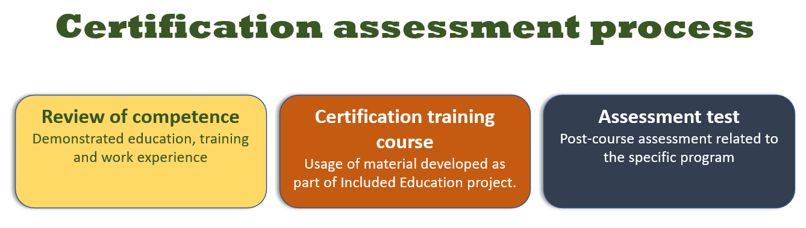

Review of competencies
The review of demonstrated education, training, and work experience will take place when an educator applies for certification. The educator will be asked to send in necessary documentation and the centre conducting the certification will review them.

Assessment after conducted eLearning
Once the Educator has applied for certification and paid the necessary certification fee, he/she will be given access to the eLearning modules supporting the applied topic.
The assessment will be conducted electronically by the educator once he/she has completed the eLearning.

Assessment after conducted face-to-face training
The assessment task connected to the face-to-face training will be assigned as part of the training. It might be conducted during the training or given with a time limitation to fulfil it.

Methodology of the three steps of assessment
In order to provide a consistent and recognizable certification system, each topic will have an assessment strategy based on the same described methodology.
The certification process will follow four principles of assessment
- Fairness
The principle is based on the individual educators’ needs being considered during the assessment process and ensuring that the educator has a clear understanding of the assessment process and is allowed to challenge the result of the assessment.
- Flexibility
The principle includes assessing the educator’s skills no matter how or when they were acquired and considering a range of assessment methods and using those that best fit the topics’ context and assessment requirements.
- Validity
The principle ensures that the assessment decision is based on evidence of performance. Essentially, it means that the assessment process does what it claims, assesses the competency of the individual educator.
- Reliability
The principle refers to the consistency of assessment outcomes, meaning that given the same conditions for the same unit of competency, all assessors should reach the same conclusion regarding the competency of the educator.

Review of competencies
The purpose of this review is to judge the educator’s education, training, and work experience. This is considered to be the “entrance ticket” for the certification process.
The review will be conducted with the purpose of being inclusive rather than exclusive, meaning appreciating many previous trainings, educations, experience, competencies etc.
The minimum requirement is relevant education, experience, and/or specific gained competence within the topic the educator is applying certification within.

Assessment after conducted eLearning
The assessment after eLearning will, with reference to Kirkpatrick’s model of evaluation, map the learning outcome.
The assessment methods in use will be:
- Digital knowledge test based on questionnaires
- Scenario-based questions and tasks
- Written open tasks to conduct.

Assessment after conducted face-to-face training
The assessment task connected to the face-to-face training will, with reference to Kirkpatrick’s model of evaluation, map post-eLearning position behavior.
The assessment methods in use will be:
- Observation of conducted teaching tasks
- Scenario based case tasks to solve
- Written open tasks to conduct.

Requirements for the certification body
Organisations planning to implement the certification process should follow some quality standards.

Management of impartiality
All certification activities must be undertaken impartially. This includes those risks that arise from its activities, from its relationships, or from the relationships of its personnel. Such a risk assessment should be a normal part of what the organization considers when implementing the certification process.

Confidentiality
The organisation conducting the certification is responsible, through legally enforceable commitments, for the management of all information obtained or created during the performance of certification activities. Except for information that the client makes publicly available, or when agreed between the certification organisation and the client (e.g. for the purpose of responding to complaints), all other information is considered proprietary information and shall be regarded as confidential. The organisation must inform the client, in advance, of the information it intends to place in the public domain.
Information about the client obtained from sources other than the client (e.g. from the complainant or from regulators) must be treated as confidential.

Changes affecting certification
When Included Education or the certification organisation introduces new or revised requirements that affect the client, it must be ensured these changes are communicated to all clients. Included Education will verify the implementation of the changes by its clients and shall take actions required by the scheme.

Termination, suspension, or withdrawal of certification
If a nonconformity with certification requirements is substantiated, either because of surveillance or otherwise, the certification organisation might consider and decide upon the appropriate action. Appropriate action can include the following:
- continuation of certification under conditions specified by the organisation (e.g. increased surveillance)
- suspension of the certification pending remedial action by the client
- withdrawal of the certification

Evaluation and revision of assessment process
The Assessment process document will be reviewed yearly, based on experiences, new practices, new policies, and better tools.

