


Customized learning

Face-to-Face training 2-4 hours
The training is conducted in present form- traditional training in a classroom/hall up to 20 attendees

Content
Learning objectives 2
Lecture start – 30 min 2
Introduction 2
Aims 3
Demonstration learning through action - 120min 4
Exercise 1 - 60 minutes 4
Exercise 2 - 60 minutes 7
Assessment for practical skills from the face-to-face training 9
Feedback form from the attendees 10
Equipment for holding the course 11

Learning objectives
- Knowledge objectives
- The school must give all students opportunities for learning and development regardless of their prerequisites.
- The teachers should involve students in assements and choices based on what is appropriate for their age, development and level of maturity.
- Customizing the training means adapting with varied forms of assessment, learning resources, learning arenas, and learning activities so that everyone gets the best possible benefit from the training.

- Skill objectives
- Map and identify individual student needs and find good and varied teachings methods while still following the curriculum.
- Be able to address the challenges and take concrete measures as part of ongoing teaching to increase students' understanding and participation in teaching
- Be able to lead a classroom where all students, regardless of their backgrounds, needs and diversity, feel a sense of belonging.
- Be able to evaluate the effect of your own measures.

Lecture start – 30 min

Introduction
The trainer welcomes the participants and introduce himself to the group. Then the training program is presented, the purpose of the training, and how long it will last. It’s important to talk about the purpose of the combination between e-learning and practical pedagogical training face to face.

To master and be able to use effective methods and tools in customized learning, these are success criteria:
- Work individual and learn how to do the methods/use the tools
- Try them out in group and share experience with others
Success story:
Tell the participants your own or someone else’s success story with a good example of customized learning.
- A student with challenges, who need personalized learning to get through school
- A student who was in risk of dropping out – what did you do to get him through school?
The trainer then performs the following task:
“Interview”
- Interview the person sitting next to you
- Who are they? Where are they from? Age? Family? Professional background?
- When you are finished trade rolls
- Then you will present the neighbour to the rest of the group

The purpose of the task:
- Most people hate presenting themselves even though it is necessary. It’s easier to present someone else.
- Trust and respect for the others
- Teambuilding
- Making all students feel at ease
This is transferable to the classroom and crucial for further learning - customized learning

Aims
During and after this training you should be able to use the following methods and tools of customized learning:

- Student mapping
- To give all your students opportunities for learning and development regardless of their prerequisites and maturity
- Map the student’s life situation, learning abilities and preferences to facilitate a training that accommodates each individual student
- Student participation
- To involve your students in assesments and choices based on age, development and level of martuinty
- Student inclusion
- How to make your students feel included in the classroom and in the school community
- How to recognize and value the diversity of students, and how to view diversity as an enrichment and resource

Demonstration learning through action - 120min
After each activity, make sure there is discussions and reflections in the full group. Please feel free to adjust the activity as long as focus is kept on the learning objectives and meet the “WHY” challenge.

Exercise 1 - 60 minutes
Why?
- To give all your students opportunities for learning and development regardless of their prerequisites and maturity
- Map the student’s life situation, learning abilities and preferences to facilitate a training that accommodates each individual student

Tasks:
- “Mind mapping”
Where are your strengths? (Are you a social person? Do you have a lot of ideas? Do you like to have a plan or are you impulsive? Do you like practical work? Do you prefer things over humans? Are you creative?)
Where are your possibilities?
How do you learn best? (In teams with others? On your own? A combination?)
What’s your interests? Skills?

Example of how it can look like:

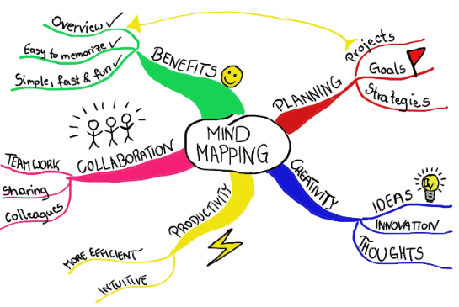

Time: 20 minutes in groups. Be prepared to share your answers.

- “My roadmap”
Create a roadmap of your life including the things, both positive and negative, that make you who you are today. You can make the map however they wish, using colors, clippings, drawings and/or words.

Example of how it can look like:
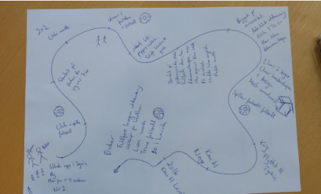

Time: 20 minutes in groups. You don’t have to share your roadmap but reflect in group how it was to make it.

- “Classroom survey”
Ask questions about how the students learn best, if they have any friends in class, their goals for school, etc. Everyone will answer, and in that way this survey will be harmless, but it will give you answers about each student.

Time: 20 minutes. Work in groups, talk about the example (handed out to you)

Instructors’ role in all tasks:
- Follow-up work in group
- Give tip or advice if they struggle
- Ask this question after the groups are finished: “How can these tasks make you as a teacher better at customized learning?”

Handout 1 - Exercise 1 (task 3 “Classroom survey”)

This is an example

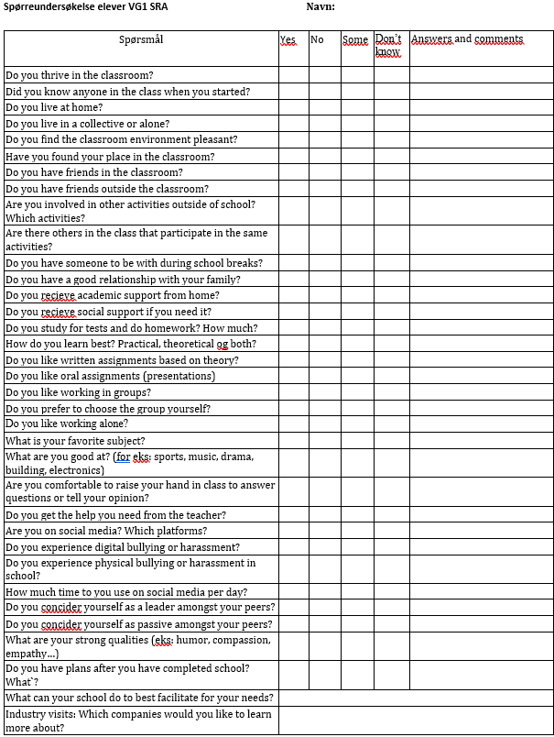

Exercise 2 - 60 minutes
Why?
- How to make your students feel included in the classroom and in the school community
- To make students participate and feel comfortable and safe with you and their fellow peers

Tasks:

- “True or false”
This is an assignment to getting to know each other. Everyone must tell two things about themselves that are true and one thing that is false. Fokus on topics that give an increased cultural understanding of who you are.
The group must guess which statements are false afterwards by voting. The group can ask questions to the teller about their topics of choice, both true stories and false.

Time: 20 minutes in groups. Do the exercise.

Instructors’ role:
- Follow-up work in group
- Give tip or advice if they struggle

- “The sun shines on me”
This assignment is about trust, connection, and empathy.
The group sits in a circle. There is one less chair than people. One stands in the middle and says «the sun shines on me and everyone who…» Everyone who relates to the statement rises and finds a new place to sit. The person who does not find a chair is in the middle. Start with simple questions, and after some tries, move on to more personal topics like mental health, bullying

Time: 20 minutes in groups. Do the exercise.

Instructors’ role:
- Follow-up work in group
- Give tip or advice if they struggle

- “Factory”
The class are workers in a factory, and they must show how effective they can be to increase production.
Everyone is in a circle. One student is the department manager and starts production by throwing 1 yarn to another student. That student throws to another (and so on) until all students has had the yarn in their hands. The students must remember who they send it to. Several yarns will be added to the production and the production will be based on time.
Find a solution together that will make the production most effective.

Time: 20 minutes in groups. Do the exercise.

Instructors’ role:
- Follow-up work in group
- Give tip or advice if they struggle

Assessment for practical skills from the face-to-face training
40 min

Case:
You have a class of 20 students. It’s the first week of a new school year.

You can already tell that some of your students have issues with dealing with school and subjects and are uncomfortable in class. You don’t know every single one of them yet, you have just read some lines from their journal.

- What would you do?
- How would you make a safe environment for everyone?
- How would you make school manageable for every student?

Help text: student mapping, student participation, student inclusion

Feedback form from the attendees
15 min

Questions for reflections:
- Do you think customized learning is important? Why?
- What skills did you enhance/learn?
- Do you think you have learned any new methods/tools you can use in teaching?
- Is customized learning so how difficult to implement? Why?

Equipment for holding the course
- Papers (white and coloured)
- Pencils (coloured)
- Scissors, glue, stickers
- Laptop/tablet/phone
- Chairs

