SOCIAL FACTORS
Face-to-Face training (2-4 hours)
The training is conducted in present form- traditional training in a classroom/hall up to 20 attendees




Contents
Learning Objectives 3
Lecture Start 3
Success Story(20min) 3
Inquiry-based learning(20min) 4
Brainstorming knowledge and experience (40 min): 4
Demonstration learning through action 5
Activity 1(60 min): 6
Activity 2(60 min): 7
Health Discussion (30 min) 7
Assessment for practical skills from the face-to-face training(40min) 8
Feedback form from the attendees (20 min) 8
Equipment for holding the course 9

Learning objectives:

Knowledge:

- Understand the training needs of your learners who are facing social challenges . Calm communication, active listening and compromise: Educators are one of the most influential persons in young people’s life. It is important for them to learn how to lay a strong foundation before the youth’s window of such opportunity closes.
- Gain knowledge of suitable training methods addressed to learners dealing with social challenges.

Skills:
- Develop the outline of your future course contents in accordance with the needs of the learners. Trainers will achieve that by using feedback from their students. Along with individual feedback (written or verbal), teachers need to provide whole-group feedback on patterns they see in the collective class' growth and areas of need. Students also need to be given opportunities to provide feedback to the teacher so that she can adjust the learning process, materials, and instruction accordingly. In our case, problem-solving is an important life skill for young people: Educators will familiarize themselves with and apply methods of helping young people learn to solve their problems by working together.

Attitude:
- Learn how to facilitate communication among their learners and how to create a safe and smooth environment for the students in order to express their real feelings.

Lecture start – 30 min
Introduction:
The trainer welcomes the participants and introduce himself to the group. Then the training program is presented, the purpose of the training, and how long it will last. It’s important to talk about the purpose of the combination between e-learning and practical pedagogical training face to face.

Success story: (20 min)
The trainer can start with a personal story for building the trust.
‘Let's start with a story that really affected me during the early years of my teaching career, with little experience in dealing with such situations. I want to share this story with you to show you the relationships of trust and strong bonds that can develop between a student and a teacher even if the circumstances are not favorable. Mary, a student of mine, struggled with substance abuse for years, from high school into adulthood. It wasn't until she was faced with the death of her dearest friend because of the drugs, she was finally able to receive treatment and let her recovery begin journey. She immediately asked for my help and together with a team of experts we helped her get back on her feet. Sarah wants to reach out to young students, especially those who face addiction challenges, with her story.’

Inquiry-based learning(20min):
2 truths 1 lie
To get to know the participants and explore their needs, making them feel comfortable we will implement the following activity.
We will give paper and pens and they will have ten minutes to write 2 truths and 1 lie about themselves.
The main instructions of the game are the following: Each member of the group introduces himself by stating two truths and one lie about themselves. The statements don't have to be intimate, life-revealing things—just simple hobbies, interests, or past experiences that make each person unique. The lie can be outrageous and wacky, or it can sound like a truth to make it harder for the other participants. One at a time, each person shares its statements. The group has to guess which statements are true and which statement is the lie. You can keep score to see who correctly guesses the most lies, or just play for fun to get to know one another—it's up to your group.
In this way the participants start to feel more comfortable with each other and through the search for the lie they start to share their personal experiences. Through personal experiences, learning needs are explored, as well as their opinions on the subject.

Brainstorming knowledge and experience (40 min):

Case Study 1:
Case study on bullying with incident of male to male- body shaming comments in front of other classmates.
Case Study 2:
Case study on toxic family members: The teacher asks learners to prepare an essay on how they spent their Christmas holidays. A 16th - year- old student girl explained the anxiety she felt because of the every-day family gatherings.
Case Study 3:
Case study on drug addiction. Each group writes a scenario on drug addiction and presents them.

After the practical cases and the scenario trainer divides the class in groups of 3 participants and gives them different case studies to. So, this will allow them to debrief, argue, and explain their ideas in the light of other reflections.

-What kind of peer pressure could a student face today?
-Have you ever been in a peer pressure situation? What did you do to face it?
-What kind of help could a teacher provide to them?
-Could personal qualities be useful for trainers to face up to these facts? Which ones?
-How would you act, face, and communicate in that situation?
-What are your feelings, your thoughts, and your concerns?

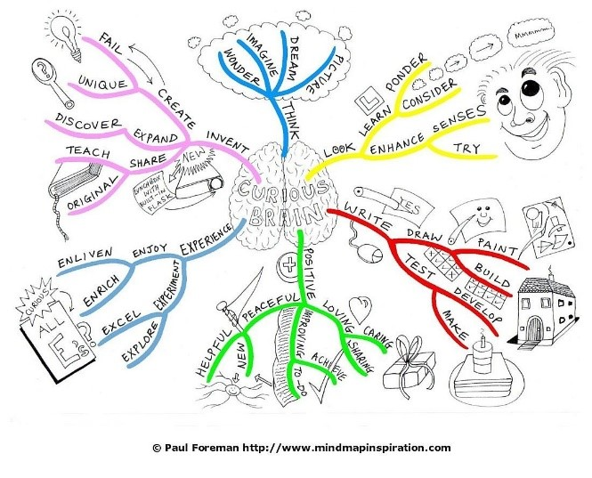

Demonstration learning through action (120min)

The trainer starts an open discussion with the participants during which they’re trying to refer to the most common real social concerns young people face. Social problems that must be refered are the following:
-Bullying
-Toxic family relationships
-Low educational family level
-Addictive substances
-Violence of any kind
-Financial problems (unemployment, low income)
After the open discussion trainer presents a powerpoint with theoretical information about social issues in education in Europe with statistical information and the problem identification.
After the problem identification trainer leads the discussion to the solution of the problem and asks participants’ ideas and opinions.
The main points for the problem’s solution are:
-Early identification
-Understanding transition
-Transferring knowledge- Metacognitive strategies
-Respect
-Rapport
-Trust and acceptance
-Communication- safe environment

ACTIVITY 1

Theatre of the oppressed activity



Participants based on the previous practical cases divided in groups write a scenario of a quick theatrical play that represents social issues. After that they present their play.
Theatre of the oppressed stimulates critical observation and representation of reality, envisioning the production of consciousness and concrete actions.
The main actors of a performance are the actors, the joker and the audience-actors. Usually the show starts with the Joker. He is the mediator between the group of actors and the audience.
An oppression scene could be about the position of somebody facing serious cosial issues. After the story is presented, the joker takes the floor again. Always keeping an impartial attitude, the joker elicits information by asking spectators about what they saw happening on stage. Did they recognize any scenes of oppression? Who was the oppressor and who was the oppressed? What in their opinion happened and did the oppressed fail to move from oppression to an ideal state?
Then, he informs them that the story will be replayed and anyone who wants to can shout «Stop!» to the point where he thinks he can prevent oppression and come on stage and take the place of the oppressed. The story plays out over and over, and the audience suggests different alternative courses of action.

ACTIVITY 2

Creating your own persona
A persona is a fictionalized representation of a group of individuals that reflects what motivates them, where they go for information, what a “day in the life” looks like, and their fears, struggles, and goals. While demographic information such as age, title, location, or years of experience are often included to “bring the persona to life” and may help nuance your use of the persona, these are not the factors that guide how a person makes decisions and thus are not the heart of persona development. The goal of developing a persona is understanding how someone behaves and makes decisions. Using this new understanding is foundational to delivering an engaging learning program.
According to the information related to the social issues that a learner may face, which was heard in the previous activity will now be used in the creation of the persona. Think of it as a big little person drawn on paper with words and phrases inside that describe him.
After this step, each group visits the person of the other group and notes on a bubble ways, tricks and solutions that will be able to help the person in his educational inclusion.
Developing effective personas entails conducting surveys, gathering anonymous data about the sources of information people consult, or, ideally, interviewing learners to get insights into the differences in how they think, behave, and make decisions. In fact, a major component of personas is understanding how someone makes decisions. This includes where they go for information.
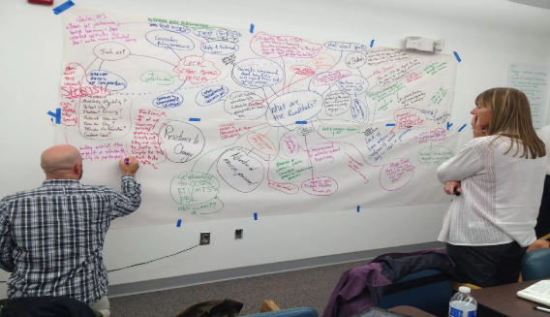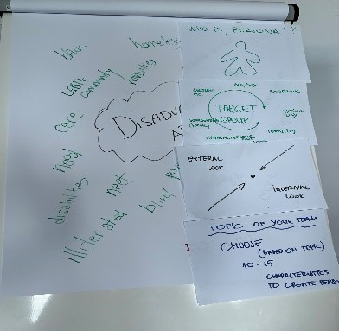

Health Discussion (30 min)

Each participant can receive great information and notes from each other through the “health discussion”, which is going to be conducted for an effective and fruitful reflection.

Assessment for practical skills from the face-to-face training(40min)

Common signs
Tests and quizzes (Kahoot, Guizlet, Quizzizz, etc.)
Case studies: For example, we have a case study of a new class, in which most of the students come from a toxic family environment. Some of them are facing with violent behavors, parents' alcoholism or drug addiction, etc.
The trainer divides the classroom into couples and ask them to discuss the following topic: (Debate Discussion)
- How would you do things differently than the protagonist teacher, who cannot create a safe environment for them with his traditional and formal educational way, using your newfound knowledge or skills?
Dream tree and flower of resource

Feedback form from the attendees (20 min)

An interesting and fun way to get feedback from participants is the 5 finger rating method. For each finger of the hand, a specific question needs to be addressed. Each finger refers to a question. By this way it’s easy to remember if you imagine gestures that would include that finger, and/or the meaning that that finger carries in our culture.
Starting from the thumb the first question is “What went well?”, going to “What could be improved?’ at the index finger. We use the middle finger for “What went wrong?” and the negative feedback. Ring finger stands for “What would you like to keep?” and the pinkie finger stands for “What did not get enough attention?”.
This way helps participants have a clear view for what they have to talk about. It is really helpful to have the visual reminder of the kind of feedback we were being asked to give, and to go through it in the order that was presented by just counting down the fingers on your hand.

Equipment for holding the course

Papers
Big paperboard
Pens or markers(different colours)
Laptops/ Tablets
Chairs

